Row Operations & Preservation of Row Spaces
The following are geometric proofs that elementary row operations does not modify the row space of a matrix.
Consider the matrix. The span of its row space isas shown in Figure 1.

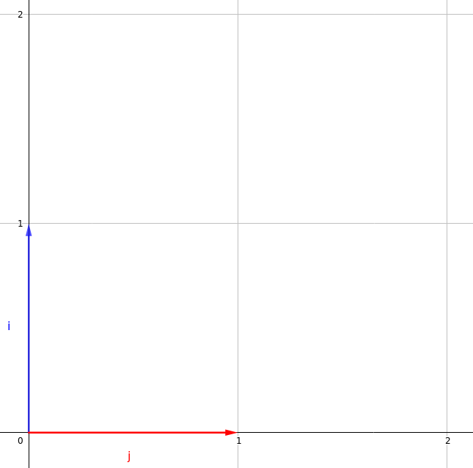Figure 1

Multiplying A Row By A Non-Zero Constant
Scaling the first row by 2, we get the matrix. The span of its row space isas shown in Figure 2.

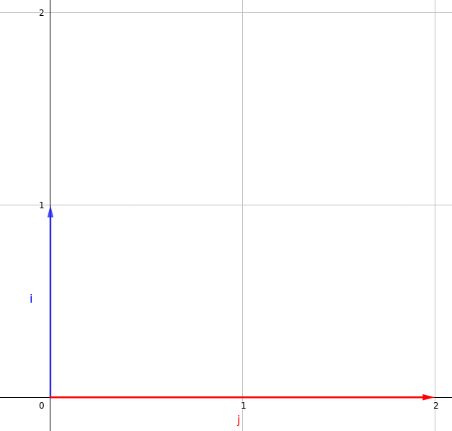Figure 2
As can be seen, the span ofandare the same.

Interchanging 2 Rows
Interchanging the 2 rows, we get the matrix. The span of its row space isas shown in Figure 3.

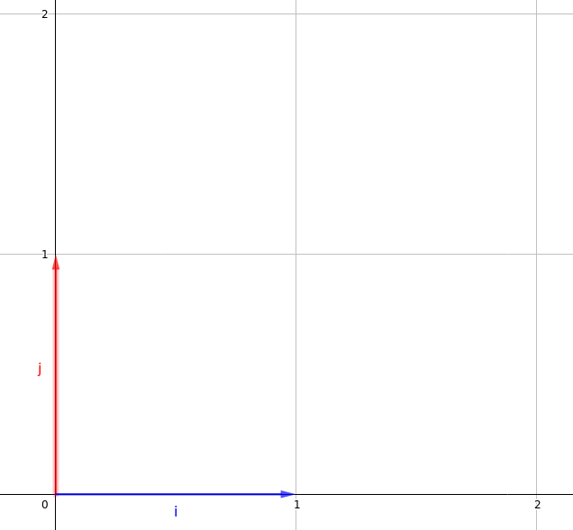Figure 3
As can be seen, the span ofandare the same.

Adding A Multiple Of A Row To Another Row
Adding the first row to the second, we get the matrix.The span of its row space isas shown in Figure 4.

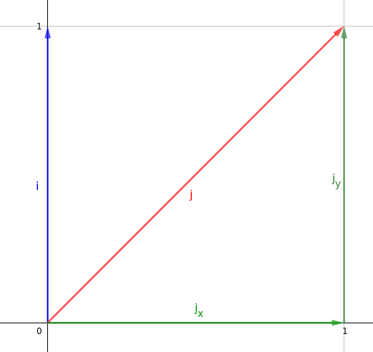Figure 4
Let.
Sinceis a linear combination ofand, any vector which can be expressed as can also be expressed as.

Thus, and the span ofandare the same.

